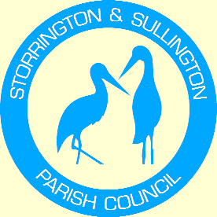
Storrington, Sullington and Washington
Neighbourhood Plan

WASHINGTON
PARISH COUNCIL

You are duly summoned to attend the Meeting to be held in The Chanctonbury Room, The Parish Hall, Thakeham Road, Storrington, on Tuesday, 8th March 2022 at 6.30pm.

A G E N D A

- To welcome and Co-opt new Member of the Steering Group (Cllr Tony Lisher)

- To agree amended Post Production Terms of Reference for the Steering Group.

- Horsham District Planning Framework – To discuss the Steering Group’s position with regard to the site selection process and to consider way forward for future meeting with HDC.

- Any other business.

Tracey Euesden
Clerk to Storrington & Sullington Parish Council 17/2/2022

